**Assignment (2)**

**Why MOSFET gate driver is needed?**

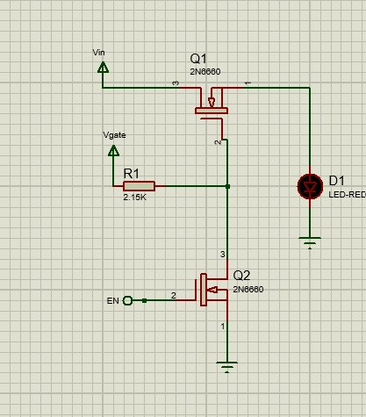A gate driver is a power amplifier that is use to amplify signal (analog or digital) provided with low-power to a high power signal used to control the on/off operation of the MOSFET at the desired frequency.

1. **Load switch circuit:**

Load switch circuit is controlled by the system of the application to provide power to the circuit in usage and cut off power to the circuits not used. When EN is low, Q2 is off and the circuit cannot switch the LED on. However, when EN is high the Vgate reaches to the gate of Q1 opening the Vin to pass to the LED turning it on.

1. **Reverse polarity protection:**

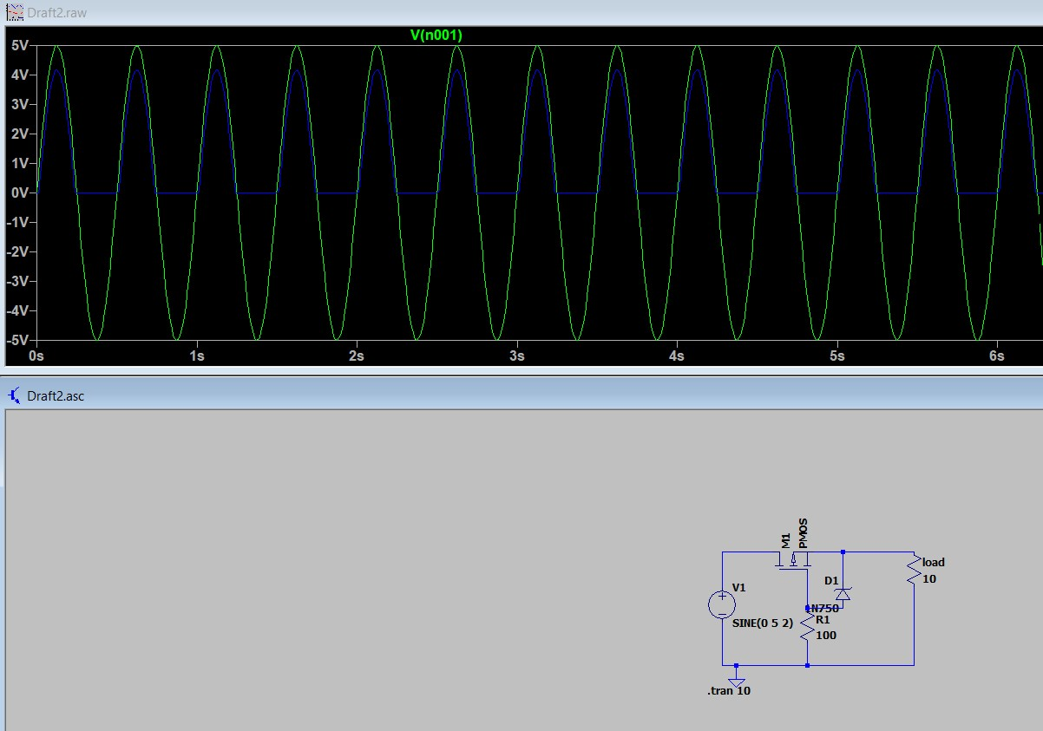The PMOS is used as a power switch that connects or disconnects the load from the power supply. During the proper connection of the power supply, the MOSFET turns on due to the proper VGS (Gate to Source Voltage). But during the Reverse polarity situation, the Gate to Source voltage is too low to turn on the MOSFET and disconnects the load from the input power supply.

1. **H-bridge:**

